**INDEX**

|  |  |  |
| --- | --- | --- |
| **S.NO** | **Content** | **Page No.** |
| **1.** | **About The Project** | **2** |
| **2.** | **Hardware Requirement**  **And Software Requirement** | **3** |
| **3.** | **Data Structure** | **4-5** |
| **4.** | **Frame Design and Coding** | **6-26** |
| **5.** | **Output Screen-1** | **27-35** |
| **6.** | **Output Screen-2** | **36-38** |
| **7.** | **Bibliography**  **And**  **Future Updation** | **39** |

**About the Project**

This Program is basically about the Online Police Service.

The User can make complain online to police through this software, it is much better and faster then making a call to police.

The system of calling to police is change to software. In case of PREVIOUS CALLING SYSTEM, it is very time taking as a USER make call to “100” and that phone call is receive by Police call center which is mostly at State Capital, and then that call is transferred to police of User nearby area. And then there is very large process of complaining. Thus, that previous system is time taking.

Whereas this software, has reduced time of both User and Police. This software directly send complain message to respective Police office of User’s Nearby Area. Thus, this software is helpful and instant service.

This software is dual-sided , Police Officer and User both can use it.

**Tested and recommended** **Hardware requirement**

* **Processor :-** Intel(R) Core(TM) i3 – 2328M

CPU @ 2,20Ghz

* **RAM :-** 2 GB
* **Bit_Processor**  :- 32 bit , x64-based processor

**Software requirement**

* Paint
* Adobe Photoshop
* MySQL
* Java Netbeans
* Microsoft Word
* GIF MAKER

**DATA STRUCTURE**

There are three tables :-

1. **A_Register :-**

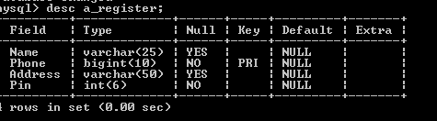

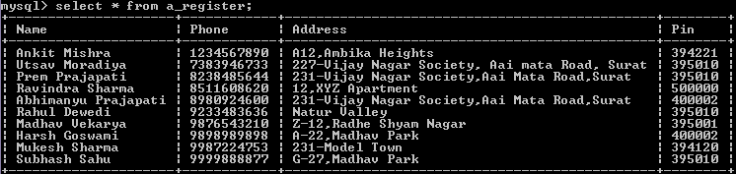

1. **Non_Register :-**

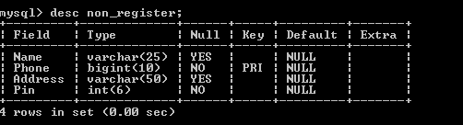



1. **Report :-**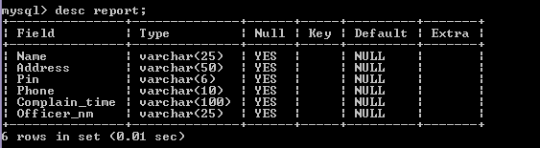

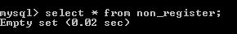

**Frame design and coding**

1. **Coding for Class to run Splash and Loading Screen**

public class screen {

public static void main(String[] args) {

splashlogo Splash1 = new splashlogo(); // It Opens Spash Screen

Splash1.setVisible(true);

try {

Thread.sleep(7000); // Time Lag 7 Seconds

} catch (InterruptedException ex) {

Logger.getLogger(screen.class.getName()).log(Level.SEVERE, null, ex);

}

Splash1.setVisible(false);

splash Splash = new splash(); // It Opens Loading Screen

Splash.setVisible(true);

try {

for (int i = 0; i <= 100; i++) {

Thread.sleep(20);

Splash.LoadingN.setText(Integer.toString(i) + "%");

Splash.LoadingBar.setValue(i);

}

Splash.setVisible(false);

new Main().setVisible(true);

} catch (Exception e) {

}

}

}

1. **Main Frame**

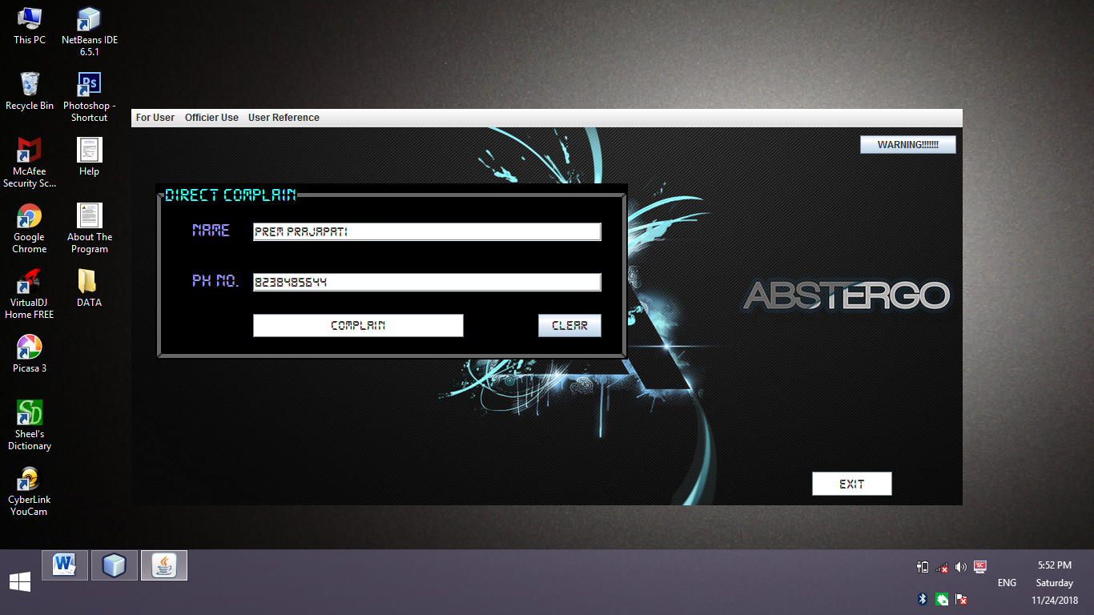

**Coding for Complain Button:-**

String Name = Nm1.getText(); // Matching the Name to find a record

String Ph = Ph1.getText(); //Matching the Phone Number to find a record

if (Ph.isEmpty()) {

Nm1.setText("");

Ph1.setText("");

JOptionPane.showMessageDialog(this, "Enter the Name and Ph.No");

}

else {

try { // Getting connection with a_register table in mysql

Class.forName("java.sql.DriverManager");

Connection con = (Connection) DriverManager.getConnection("jdbc:mysql://localhost:3306/Abstergo", "root", "");

Statement stmt = (Statement) con.createStatement();

String query = "SELECT * FROM a_register WHERE Phone=" + Ph + ";";

ResultSet rs = stmt.executeQuery(query);

if (rs.next()) {

Name = rs.getString("name");

String PIN = rs.getString("Pin");

String Address = rs.getString("Address");

Nm1.setText(Name);

t2.setText(PIN);

ta1.setText("Name :" + Name + '\n' + "Address :" + Address + '\n' + PIN);

String Complain1 = ta1.getText();

this.setVisible(false);

new Complain(Ph).setVisible(true);

} else

{

JOptionPane.showMessageDialog(this, "Sorry!!!! No Such Record Found .. PLEASE Register First"); // This part is executed if no matching record is found

}

} catch (Exception e) {

JOptionPane.showMessageDialog(this, e.getMessage());

Nm1.setText("");

Ph1.setText("");

}

}

**Coding for Clear Button:-**

Nm1.setText("");

t2.setText("");

Ph1.setText("");

**Coding for Exit Button :-**

System.exit(0);

**Code for Warning Button :-**

JOptionPane.showMessageDialog(null, " There can be a call after making complain to confirm the USER's Complain. \n" + "Invalid Complain can charge Rs.10000. & 1 Week Imprisonment.");

1. **To Register Frame**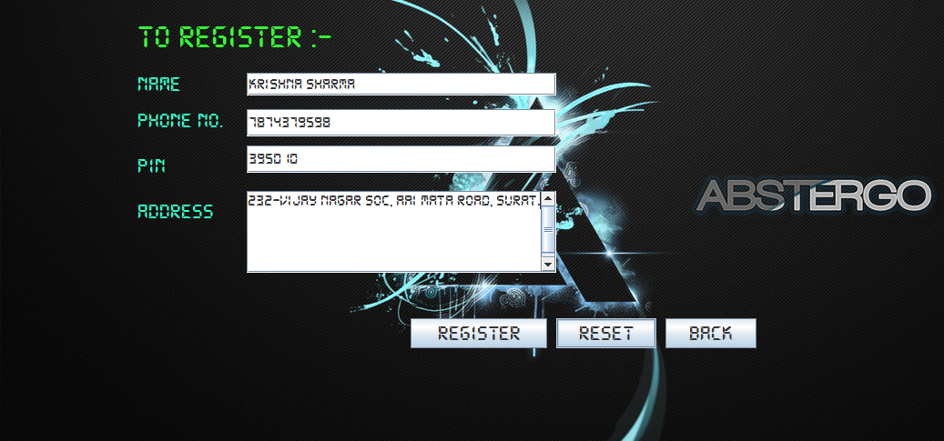

**CODING FOR REGISTER BUTTON :-**

String Name = Nm2.getText(); // Receiving Data from USER

String Address = Ad1.getText();

String PIN = PIN1.getText();

String Ph = Ph2.getText();

if (Name.isEmpty()) {

JOptionPane.showMessageDialog(this, "Name not Entered");

} else if (Address.isEmpty()) {

JOptionPane.showMessageDialog(this, "Address not Entered");

} else if (PIN.isEmpty()) {

JOptionPane.showMessageDialog(this, "PIN not Entered");

} else if (Ph.isEmpty()) {

JOptionPane.showMessageDialog(this, "Ph not Entered");

} else {

try { // Getting Connection with A_register table in mysql

Class.forName("java.sql.DriverManager");

Connection con = (Connection) DriverManager.getConnection("jdbc:mysql://localhost:3306/abstergo", "root", "");

Statement stmt = (Statement) con.createStatement();

String query = "INSERT INTO A_Register VALUES('" + Name + "'," + Ph + ",'" + Address + "','" + PIN + "');";

stmt.executeUpdate(query);

JOptionPane.showMessageDialog(null, "You are now being REGISTERED..");

this.setVisible(false);

new Main(Ph).setVisible(true); // Transfer Phone No. to Main Frame

} catch (Exception e) {

JOptionPane.showMessageDialog(this,"Please, Enter appropiate detail in appropiate field.");

}

}

**CODING FOR RESET BUTTON :-**

Nm2.setText("");

Ad1.setText("");

PIN1.setText("");

Ph2.setText("");

**CODING FOR BACK BUTTON :-**

this.setVisible(false);

new Main().setVisible(true);

1. **Non_ Register Frame**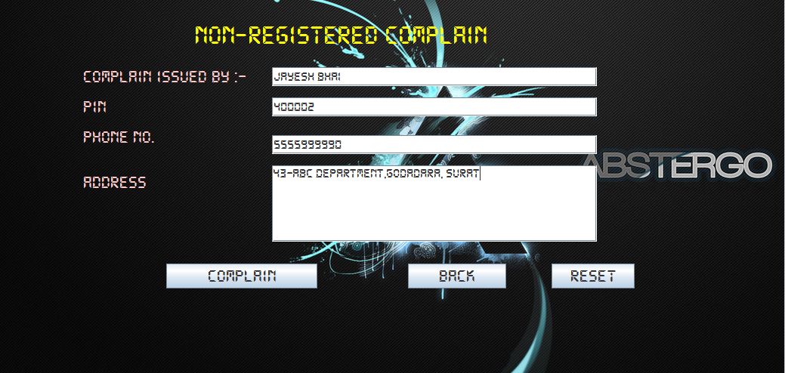  
   **Coding for Complain Button :-**

String Name = NmC1.getText(); // Entering Name , PIN, Phone, Address by USER

String PIN = PIN2.getText();

String Ph = Ph3.getText();

String Add = Ad2.getText();

if (Name.isEmpty()) {

JOptionPane.showMessageDialog(this, "Name not Entered");

} else if (Add.isEmpty()) {

JOptionPane.showMessageDialog(this, "Address not Entered");

} else if (PIN.isEmpty()) {

JOptionPane.showMessageDialog(this, "PIN not Entered");

} else if (Ph.isEmpty()) {

JOptionPane.showMessageDialog(this, "Ph not Entered");

} else {

try { // Getting connection with non_register table in mysql

Class.forName("java.sql.DriverManager");

Connection con = (Connection) DriverManager.getConnection("jdbc:mysql://localhost:3306/abstergo", "root", "");

Statement stmt = (Statement) con.createStatement();

String query = "INSERT INTO non_Register VALUES('" + Name + "','" + Ph + "','" + Add + "','" + PIN + "');";

stmt.executeUpdate(query);

this.setVisible(false);

new Non_RComplain(Ph).setVisible(true);

} catch (Exception e) {

JOptionPane.showMessageDialog(this, "Please, Enter appropiate detail in appropiate field.");

NmC1.setText("");

PIN2.setText("");

Ad2.setText("");

Ph3.setText("");

}

}

**Coding For RESET Button :-**

NmC1.setText("");

PIN2.setText("");

Ad2.setText("");

Ph3.setText("");

**Coding For Back Button:-**

this.setVisible(false);

new Main().setVisible(true);

1. **Complain Frame for USER**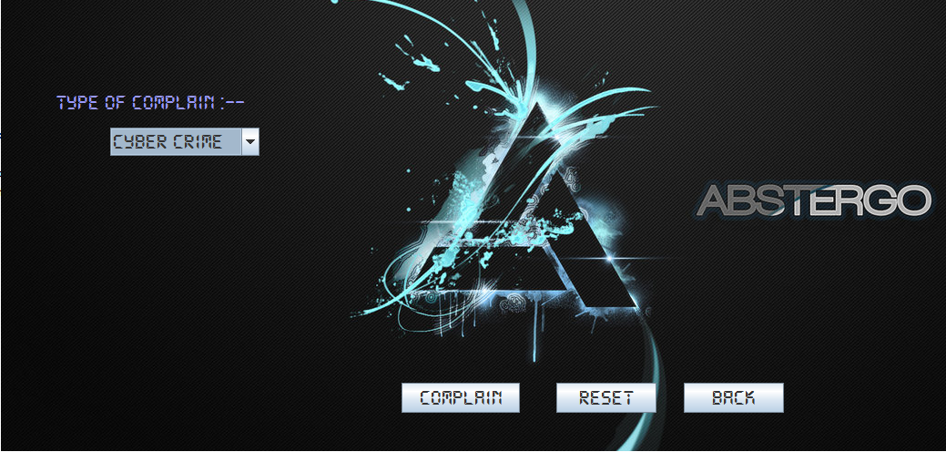

**Coding For Complain Button:-**

String Ph = Trans.getText();

String result = L1.getText();

if (Case1.getSelectedItem() == "Others") {

Panel1.setVisible(true);

Case2.setVisible(true);

Case1.setVisible(false);

L2.setVisible(false);

}

String other1 = Case2.getText();

// Search the table to find a record matching

try { // Getting connection with a_register table in mysql

Class.forName("java.sql.DriverManager");

Connection con = (Connection) DriverManager.getConnection("jdbc:mysql://localhost:3306/Abstergo", "root", "");

Statement stmt = (Statement) con.createStatement();

String query = "SELECT *,sysdATE() FROM a_register WHERE phone='" + Ph + "';";

ResultSet rs = stmt.executeQuery(query);

if (rs.next()) {

String Name = rs.getString("name");

String PIN = rs.getString("Pin");

String Address = rs.getString("Address");

String Tnd = rs.getString("sysdate()");

int ans = JOptionPane.showConfirmDialog(this, "Name :" + Name + '\n' + "Address :" + Address + '\n' + PIN + '\n' + "Type of complain:-" + result + other1 + '\n' + "Ph:-" + Ph + '\n' + "Time and date :-" + Tnd, "Confirm your information", JOptionPane.YES_NO_OPTION);

if (ans == 0) {

JOptionPane.showMessageDialog(null, "Your Complain has been done.......YOU WILL GET RESULT SOON");

String s1 = Ph + '\n' + "Type of complain:-" + result + other1 + " " + Tnd + "1";

this.setVisible(false);

new Main(s1).setVisible(true);

}

else {

Case2.setVisible(false);

Case1.setVisible(true);

Case1.setSelectedIndex(-1);

Trans.setVisible(false);

Panel1.setVisible(false);

L1.setVisible(false);

BCom.setVisible(false);

L2.setVisible(true);

} }

} catch (Exception e) {

JOptionPane.showMessageDialog(this, e.getMessage());

}

**Coding For RESET Button :-**

Case1.setVisible(true);

L2.setVisible(true);

Case2.setVisible(false);

Panel1.setVisible(false);

Case1.setSelectedIndex(-1);

Case2.setText("");

BCom.setVisible(false);

**Coding For BACK Button:-**

this.setVisible(false);

new Main().setVisible(true);

1. **Complain Frame for USER** 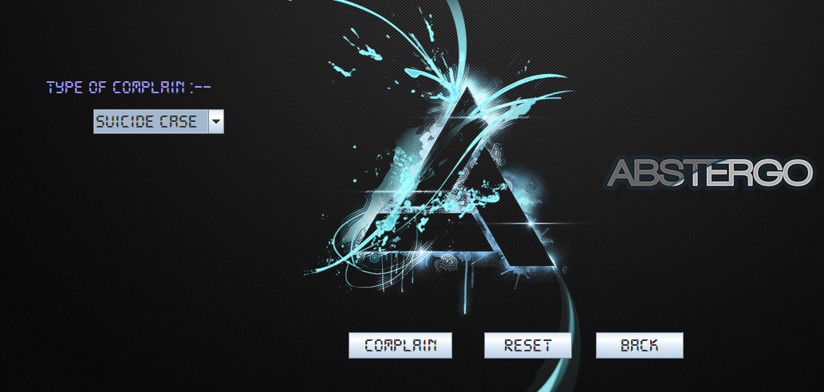

**Coding For Complain Button :-**

String Ph = Trans.getText();

String result = L1.getText();

if (Case1.getSelectedItem() == "Others") {

Panel1.setVisible(true);

Case2.setVisible(true);

Case1.setVisible(false);

L2.setVisible(false);

}

String other1 = Case2.getText();

// Search the table to find a record matching

try { // Getting connection with non_register table in mysql

Class.forName("java.sql.DriverManager");

Connection con = (Connection) DriverManager.getConnection("jdbc:mysql://localhost:3306/Abstergo", "root", "");

Statement stmt = (Statement) con.createStatement();

String query = "SELECT *,sysdATE() FROM non_register WHERE phone='" + Ph + "';";

ResultSet rs = stmt.executeQuery(query);

if (rs.next()) {

String Name = rs.getString("name");

String PIN = rs.getString("Pin");

String Address = rs.getString("Address");

String Tnd = rs.getString("sysdate()");

int ans = JOptionPane.showConfirmDialog(this, "Name :" + Name + '\n' + "Address :" + Address + '\n' + PIN + '\n' + "Type of complain:-" + result + other1 + '\n' + "Ph:-" + Ph + '\n' + "Time and date :-" + Tnd, "Confirm your information" + "2", JOptionPane.YES_NO_OPTION);

if (ans == 0) {

JOptionPane.showMessageDialog(null, "Your Complain has been done.......YOU WILL GET RESULT SOON");

String s1 = Ph + '\n' + "Type of complain:-" + result + other1 + " " + Tnd;

this.setVisible(false);

new Main(s1).setVisible(true);

} else {

Case2.setVisible(false);

Case1.setVisible(true);

Case1.setSelectedIndex(-1);

Trans.setVisible(false);

Panel1.setVisible(false);

L1.setVisible(false);

BCom.setVisible(false);

L2.setVisible(true);

}

}

} catch (Exception e) {

JOptionPane.showMessageDialog(this, e.getMessage());

}

**Coding for RESET Button:-**

Case1.setVisible(true);

L2.setVisible(true);

Case2.setVisible(false);

Panel1.setVisible(false);

Case1.setSelectedIndex(-1);

Case2.setText("");

BCom.setVisible(false);

**Coding For Back Button :-**

this.setVisible(false);

new Main().setVisible(true);

1. **LOGIN FRAME FOR OFFICER**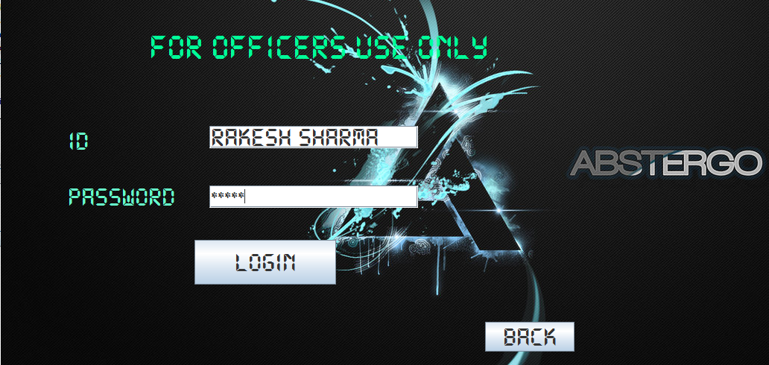

**Coding for LOGIN Button :-**

String Id = ID.getText();

String detail = Ph1.getText();

int Dl = detail.length();

String Name = "";

String PIN = "";

String Address = "";

String M = "", n = "";

for (int i = 1; i <= 10; ++i) {

String C = detail.substring(i - 1, i);

M = M + C;

}

String RunRs = detail.substring(Dl - 1);

Ph2.setText(M);

for (int j = 11; j <= Dl; ++j) {

String D = detail.substring(j - 1, j);

n = n + D;

}

detail = M + '\n' + n;

String Ph = Ph2.getText();

if (RunRs.equals("1")) { // Getting Connection with a_register table.

try {

Class.forName("java.sql.DriverManager");

Connection con = (Connection) DriverManager.getConnection("jdbc:mysql://localhost:3306/Abstergo", "root", "");

Statement stmt = (Statement) con.createStatement();

String query = "SELECT * FROM a_register WHERE phone='" + Ph + "';";

ResultSet rs = stmt.executeQuery(query);

if (rs.next()) {

Name = rs.getString("name");

PIN = rs.getString("Pin");

Address = rs.getString("Address");

t1.setText(PIN);

}

} catch (Exception e) {

JOptionPane.showMessageDialog(this, e.getMessage());

}

} else {

try { // Getting Connection with non_register table.

Class.forName("java.sql.DriverManager");

Connection con = (Connection) DriverManager.getConnection("jdbc:mysql://localhost:3306/Abstergo", "root", "");

Statement stmt = (Statement) con.createStatement();

String query = "SELECT * FROM non_register WHERE phone='" + Ph + "';";

ResultSet rs = stmt.executeQuery(query);

if (rs.next()) {

Name = rs.getString("name");

PIN = rs.getString("Pin");

Address = rs.getString("Address");

t1.setText(PIN);

}

} catch (Exception e) {

JOptionPane.showMessageDialog(this, e.getMessage());

}

} String send2 = "Name :" + Name + '\n' + "Address :" + Address + '\n' + "Pin:-" + PIN + '\n' + "Ph:-" + detail;

String PIN1 = t1.getText();

String P = new String(PASS.getPassword());

if (P.equals("12345") && (Id.equals("rakesh sharma") || Id.equals("RAKESH SHARMA"))) {

if (PIN1.equals("395010")) {

try { // Getting Connection with report table.

Class.forName("java.sql.DriverManager");

Connection con = (Connection) DriverManager.getConnection("jdbc:mysql://localhost:3306/abstergo", "root", "");

Statement stmt = (Statement) con.createStatement();

String query1 = "INSERT INTO report VALUES('" + Name + "','" + Address + "','" +PIN + "','" +M + "','" + n + "','" + Id + "');";

stmt.executeUpdate(query1);

} catch (Exception e) {

JOptionPane.showMessageDialog(this, e.getMessage());

}

this.setVisible(false);

new Non_User_Report(send2).setVisible(true);

} else {

this.setVisible(false);

new Non_User_Report().setVisible(true);

}

} else if (P.equals("12345") && (Id.equals("SARTAJ SINGH") || Id.equals("satraj singh"))) {

if (PIN1.equals("500000")) { try {

Class.forName("java.sql.DriverManager"); // Getting Connection with report table.

Connection con = (Connection) DriverManager.getConnection("jdbc:mysql://localhost:3306/abstergo", "root", "");

Statement stmt = (Statement) con.createStatement();

String query1 = "INSERT INTO report VALUES('" + Name + "','" + Address + "','" +PIN + "','" +M + "','" + n + "','" + Id + "');";

stmt.executeUpdate(query1);

} catch (Exception e) {

JOptionPane.showMessageDialog(this, e.getMessage());

}

this.setVisible(false);

new Non_User_Report(send2).setVisible(true);

} else {

this.setVisible(false);

new Non_User_Report().setVisible(true);

}

}else if (P.equals("12345") && (Id.equals("GOPAL GAITONDE") || Id.equals("gopal gaitonde"))) {

if (PIN1.equals("395001")) {

try {

// Getting Connection with report table.

Class.forName("java.sql.DriverManager");

Connection con = (Connection) DriverManager.getConnection("jdbc:mysql://localhost:3306/abstergo", "root", "");

Statement stmt = (Statement) con.createStatement();

String query1 = "INSERT INTO report VALUES('" + Name + "','" + Address + "','" +PIN + "','" +M + "','" + n + "','" + Id + "');";

stmt.executeUpdate(query1);

} catch (Exception e) {

JOptionPane.showMessageDialog(this, e.getMessage());

}

this.setVisible(false);

new Non_User_Report(send2).setVisible(true);

} else {

this.setVisible(false);

new Non_User_Report().setVisible(true);

}

}else if (P.equals("abstergo12345") && (Id.equals("ACP PRADHYUMAN") || Id.equals("acp pradhyuman"))) {

this.setVisible(false);

new Report().setVisible(true);

}

else if (P.equals("12345") && (Id.equals("SHINGHAM SIKRE") || Id.equals("shingham sikre"))) {

if (PIN1.equals("400001")) {

try {

Class.forName("java.sql.DriverManager"); // Getting Connection with report table.

Connection con = (Connection) DriverManager.getConnection("jdbc:mysql://localhost:3306/abstergo", "root", "");

Statement stmt = (Statement) con.createStatement();

String query1 = "INSERT INTO report VALUES('" + Name + "','" + Address + "','" +PIN + "','" +M + "','" + n + "','" + Id + "');";

stmt.executeUpdate(query1);

} catch (Exception e) {

JOptionPane.showMessageDialog(this, e.getMessage());

}

this.setVisible(false);

new Non_User_Report(send2).setVisible(true);

} else {

this.setVisible(false);

new Non_User_Report().setVisible(true);

}

}

else {JOptionPane.showMessageDialog(null, "WRONG PASSWORD");

ID.setText("");

PASS.setText("");}

System.out.print(PIN1);

**Coding for BACK Button :-**

this.setVisible(false);

new Main().setVisible(true);

1. **Non_User_Report Frame**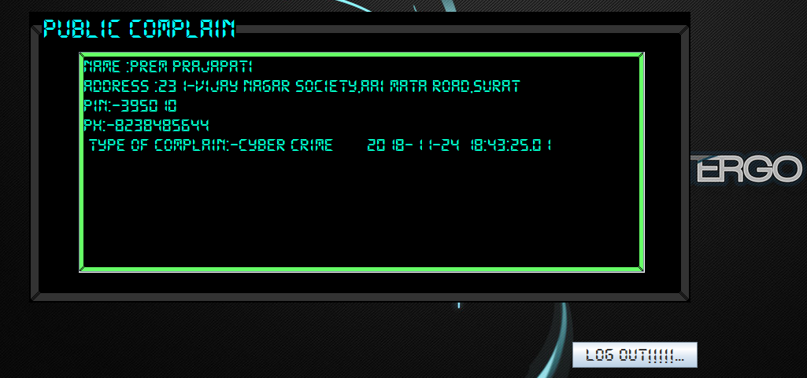

**Coding for LOG OUT!! Button :-**

try {

// Getting connection with non_register table in mysql

Class.forName("java.sql.DriverManager");

Connection con = (Connection) DriverManager.getConnection("jdbc:mysql://localhost:3306/abstergo", "root", "");

Statement stmt = (Statement) con.createStatement();

String delete = "delete from non_register;";

stmt.executeUpdate(delete);

} catch (Exception e) {

JOptionPane.showMessageDialog(this, e.getMessage());

}

this.setVisible(false);

new Main().setVisible(true);

1. **Report Frame**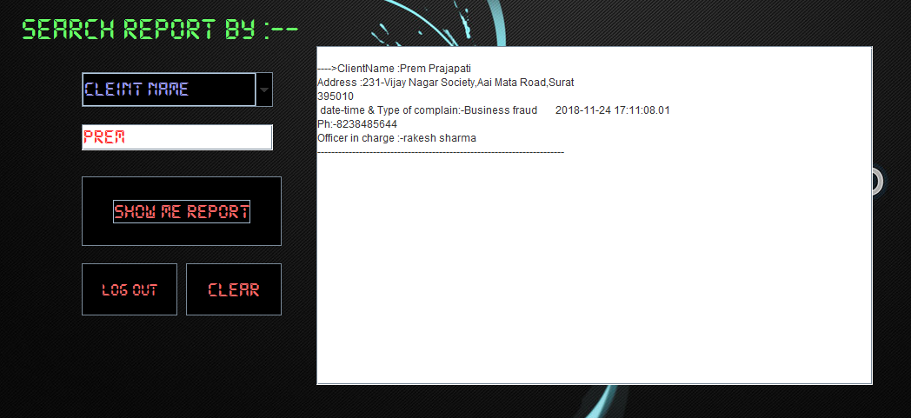

**Coding For SHOW ME REPORT Button :-**

String R = ONm.getText(); // User input the detail

if(Search.getSelectedIndex()==0)

try {Rpt.setVisible(true); // Report Displaying Area

// Getting Connection with Report table in mysql.

Class.forName("java.sql.DriverManager");

Connection con = (Connection) DriverManager.getConnection("jdbc:mysql://localhost:3306/Abstergo", "root", "");

Statement stmt = (Statement) con.createStatement();

String query = "SELECT * from report where name like '%"+R+"%';";

ResultSet rs = stmt.executeQuery(query);

if (rs.next()) {

String Cname = rs.getString("name");

String PIN = rs.getString("Pin");

String Address = rs.getString("Address");

String phone=rs.getString("Phone");

String Pname=rs.getString("officer_nm");

String Com=rs.getString("Complain_time");

Rpt.append ('\n'+ "---->ClientName :" + Cname + '\n' + "Address :" + Address + '\n' + PIN + '\n' + " date-time &" + Com + '\n' + "Ph:-" + phone+ '\n' + "Officer in charge :-" + Pname+'\n'+"-----------------------------------------------------------------------");

} else {

JOptionPane.showMessageDialog(this, "Sorry!!!! No Such Record Found .."); // This part is executed if no matching record is found

}

} catch (Exception e){}

else if(Search.getSelectedIndex()==1 || Search.getSelectedIndex()==5 ){

try {Rpt.setVisible(true);

Class.forName("java.sql.DriverManager");

// Getting Connection with Report table in mysql.

Connection con = (Connection) DriverManager.getConnection("jdbc:mysql://localhost:3306/Abstergo", "root", "");

Statement stmt = (Statement) con.createStatement();

String query = "SELECT * from report where Pin like '%"+R+"%' or Officer_nm like '%"+R+"%';";

ResultSet rs = stmt.executeQuery(query);

if (rs.next()) {

String Cname = rs.getString("name");

String PIN = rs.getString("Pin");

String Address = rs.getString("Address");

String phone=rs.getString("Phone");

String Pname=rs.getString("officer_nm");

String Com=rs.getString("Complain_time");

Rpt.append ('\n'+ "---->ClientName :" + Cname + '\n' + "Address :" + Address + '\n' + PIN + '\n' + " date-time &" + Com + '\n' + "Ph:-" + phone+ '\n' + "Officer in charge :-" + Pname+'\n'+"-----------------------------------------------------------------------");

} else {

JOptionPane.showMessageDialog(this, "Sorry!!!! No Such Record Found .. "); // This part is executed if no matching record is found

}

} catch (Exception e){}}

else if(Search.getSelectedIndex()==2 || Search.getSelectedIndex()==3 || Search.getSelectedIndex()==4){

try {Rpt.setVisible(true);

Class.forName("java.sql.DriverManager");

// Getting Connection with Report table in mysql.

Connection con = (Connection) DriverManager.getConnection("jdbc:mysql://localhost:3306/Abstergo", "root", "");

Statement stmt = (Statement) con.createStatement();

String query = "SELECT * from report where complain_time like '%"+R+"%';" ;

ResultSet rs = stmt.executeQuery(query);

if (rs.next()) {

String Cname = rs.getString("name");

String PIN = rs.getString("Pin");

String Address = rs.getString("Address");

String phone=rs.getString("Phone");

String Pname=rs.getString("officer_nm");

String Com=rs.getString("Complain_time");

Rpt.append ('\n'+ "---->ClientName :" + Cname + '\n' + "Address :" + Address + '\n' + PIN + '\n' + " date-time &" + Com + '\n' + "Ph:-" + phone+ '\n' + "Officer in charge :-" + Pname+'\n'+"-----------------------------------------------------------------------");

} else {

JOptionPane.showMessageDialog(this, "Sorry!!!! No Such Record Found .."); // This part is executed if no matching record is found

}

} catch (Exception e){}}

else if(Search.getSelectedIndex()==6 ){

try {Rpt.setVisible(true);

Class.forName("java.sql.DriverManager");

// Getting Connection with Report table in mysql.

Connection con = (Connection) DriverManager.getConnection("jdbc:mysql://localhost:3306/Abstergo", "root", "");

Statement stmt = (Statement) con.createStatement();

String query = "SELECT * from report where phone like '%"+R+"%';" ;

ResultSet rs = stmt.executeQuery(query);

if (rs.next()) {

String Cname = rs.getString("name");

String PIN = rs.getString("Pin");

String Address = rs.getString("Address");

String phone=rs.getString("Phone");

String Pname=rs.getString("officer_nm");

String Com=rs.getString("Complain_time");

Rpt.append('\n'+ "---->ClientName :" + Cname + '\n' + "Address :" + Address + '\n' + PIN + '\n' + " date-time &" + Com + '\n' + "Ph:-" + phone+ '\n' + "Officer in charge :-" + Pname+'\n'+"-----------------------------------------------------------------------");

} else {

JOptionPane.showMessageDialog(this, "Sorry!!!! No Such Record Found .."); // This part is executed if no matching record is found

}

} catch (Exception e){}}

**Coding For LOG OUT Button :-**

this.setVisible(false);

new Main().setVisible(true);

**Coding for CLEAR Button :-**

Rpt.setText("");

**OUTPUT SCREEN-1**

OUTPUT WITH CORRECT DATA

 

1)Inputing registered data

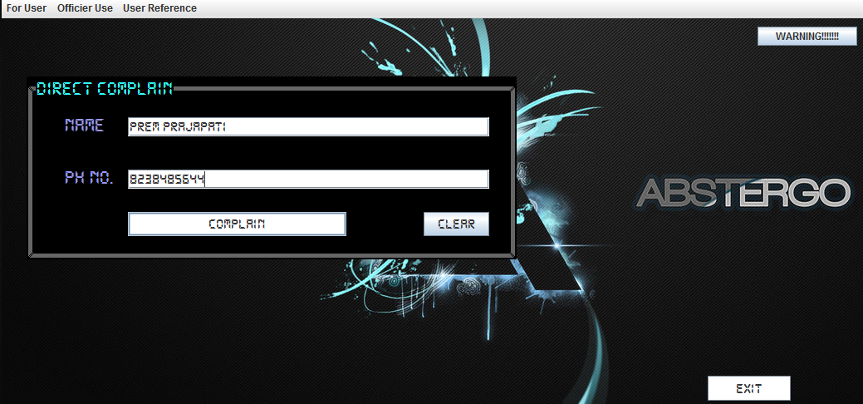

2)Clicking Complain button

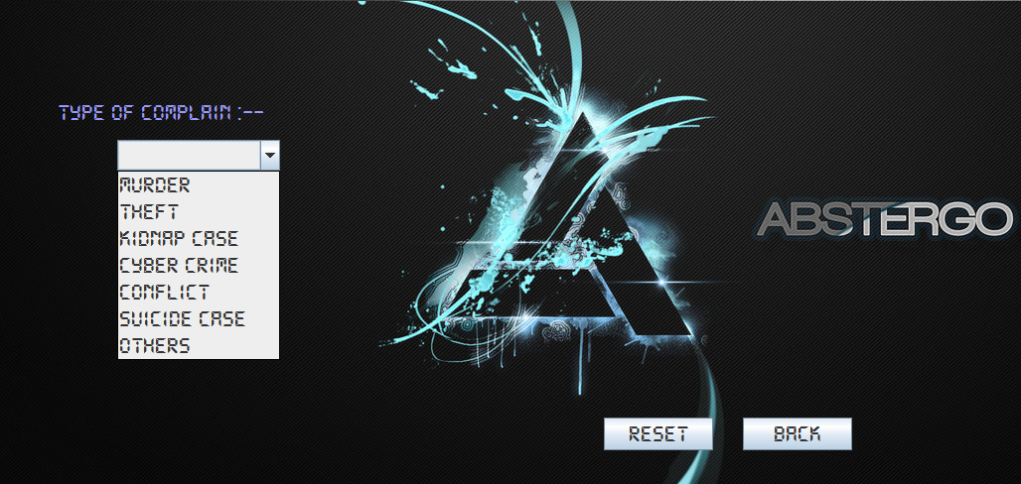

3)Option in complain button

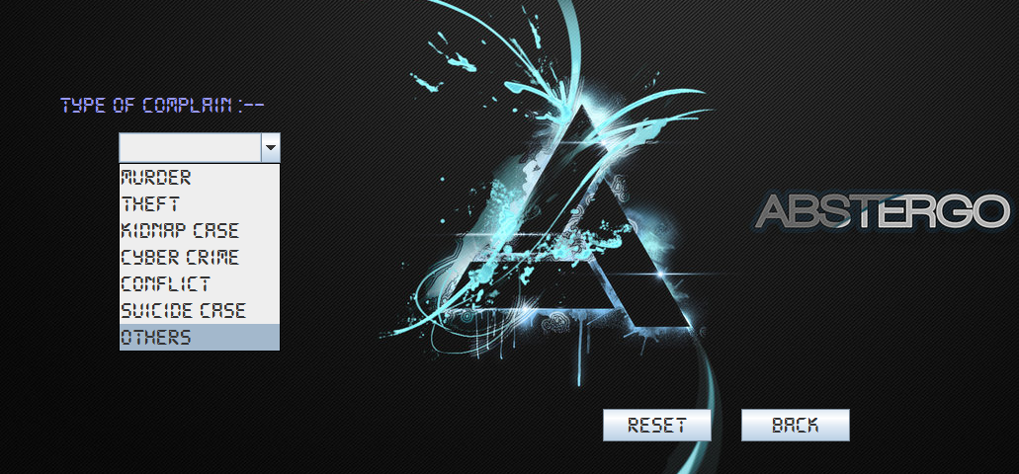

4)Selecting other option in combobox

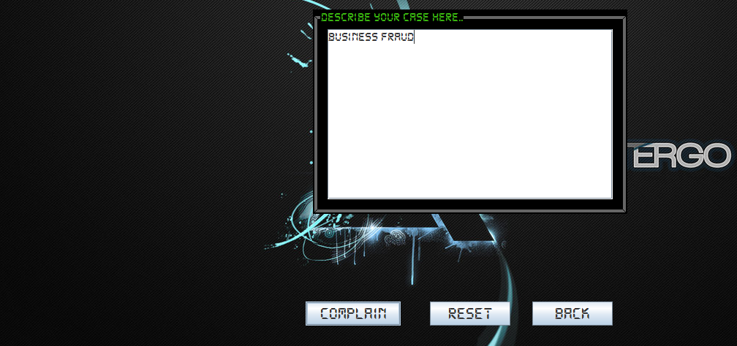  
5)Finally clicking complain button

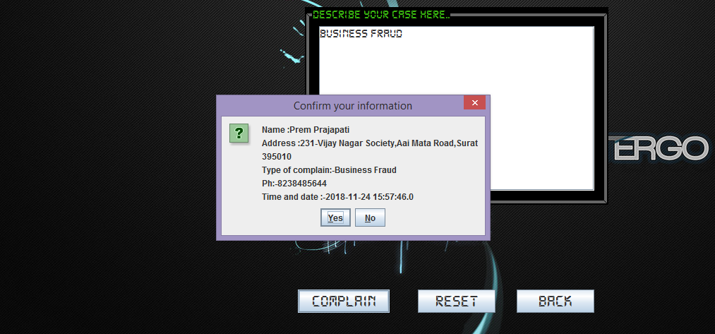

6) Confirming the given DETAIL

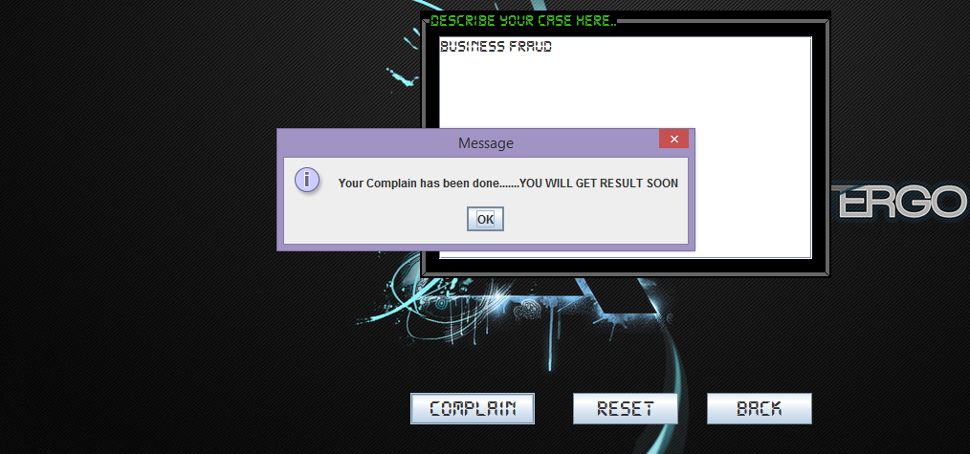

7). Clicked on BACK button, then Selecting Non_User

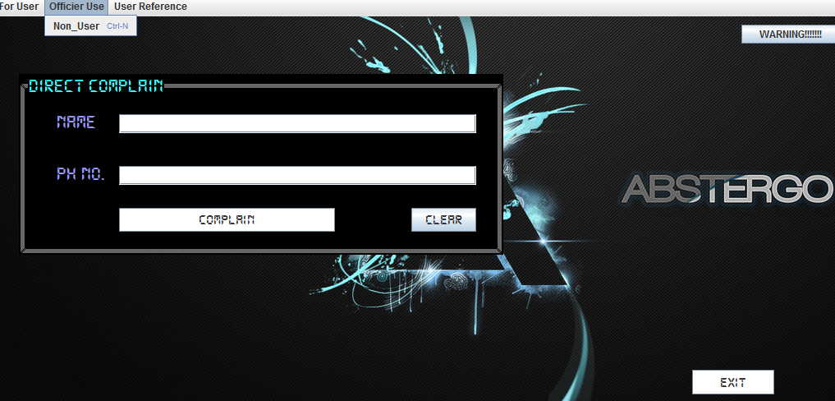

8) Clicking on LOGIN Button:-

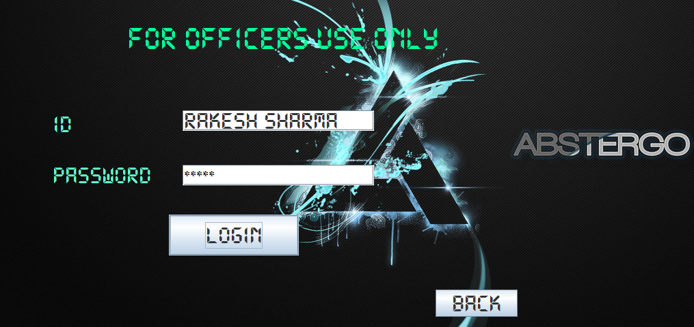

9) It Show, the COMPLAIN made by USER.

Now , Clicking on LOG OUT button:-

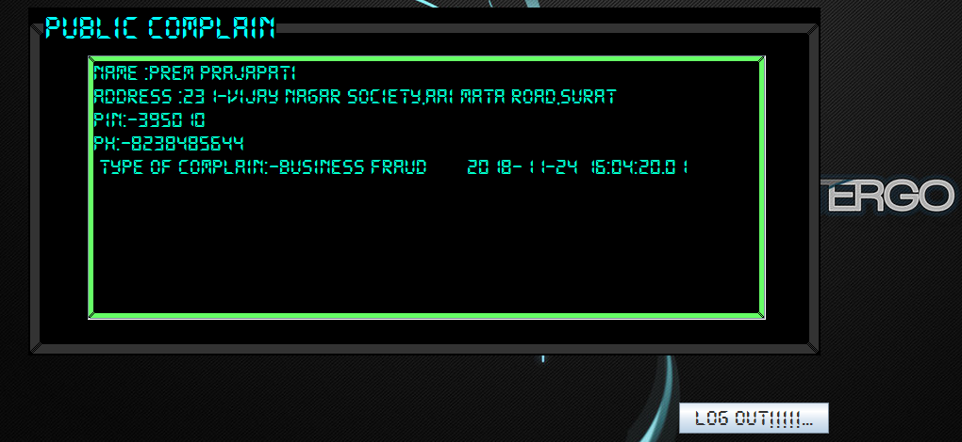

10) Main Screen Opens, Now Clicking on WARNING Button

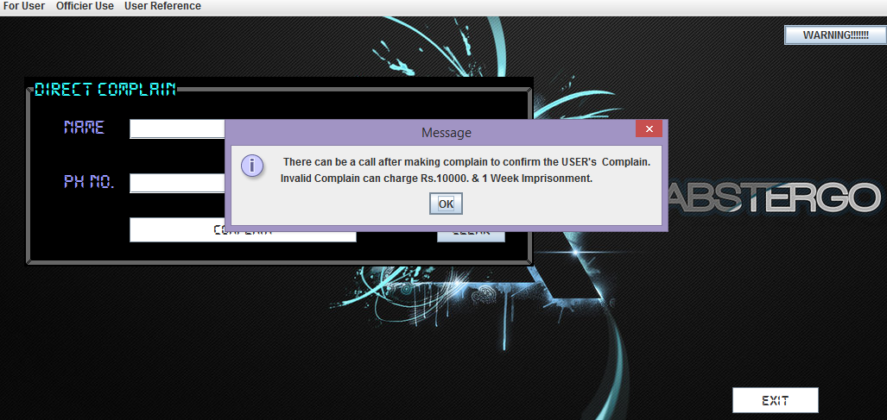

11) Going for Registration

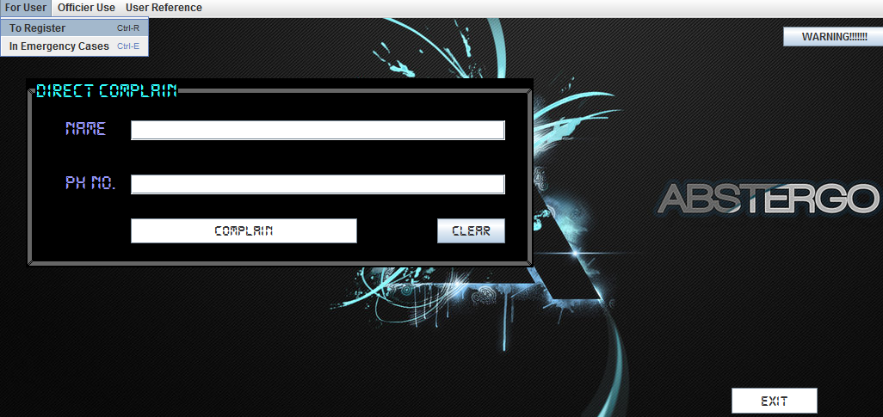

12) New USER, click on REGISTER button:-

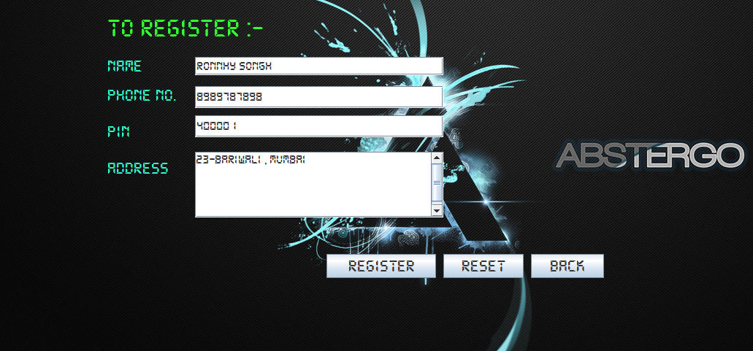

13) User is now Registered.

After Clicking on OK button, Main Screen will appear.

And then, the USER can go for Complain.

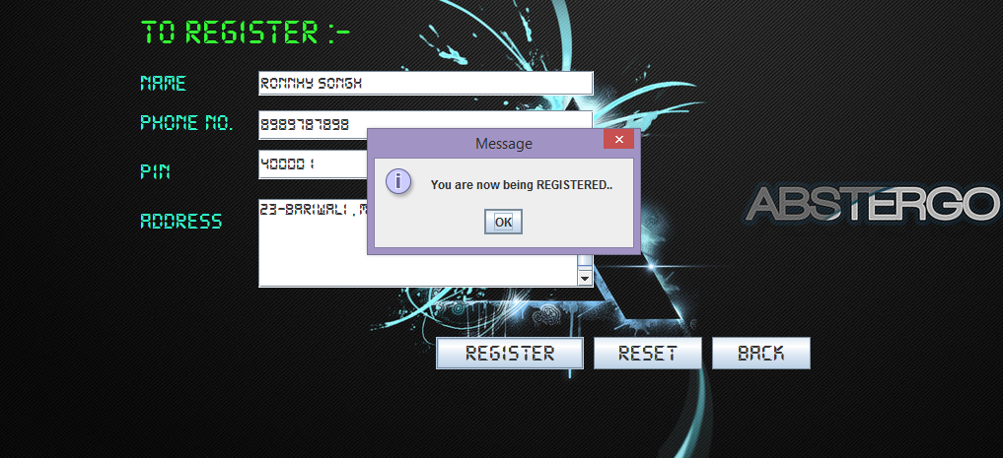

14) Any Non_User, can go for Emergency Cases

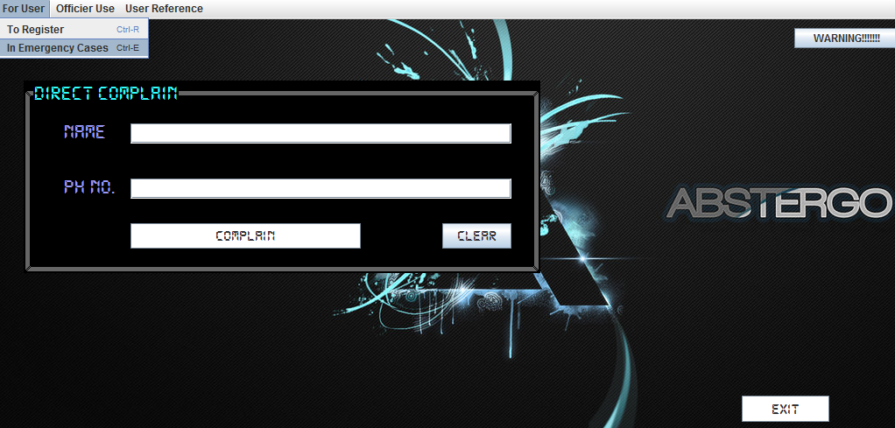

15) Clicking on Complain :-

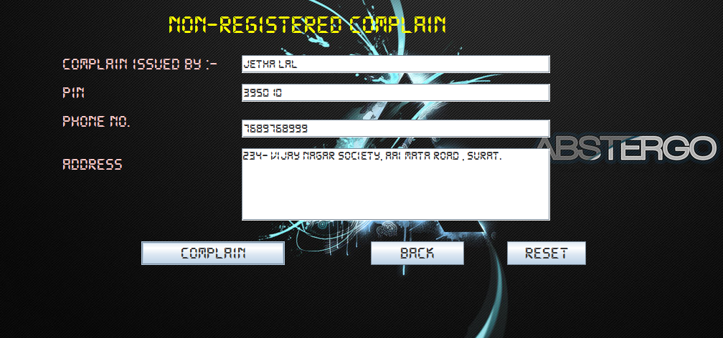

16)Then , Same process of Complaining

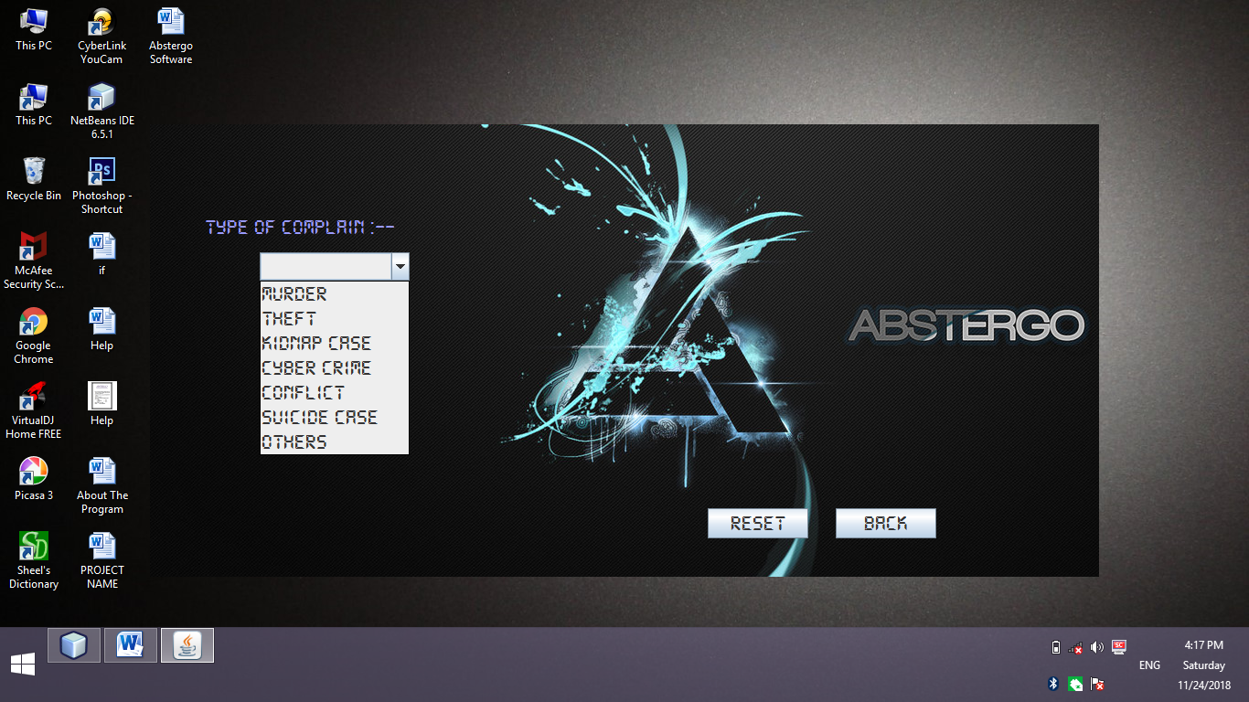

17) The Main Head, can access to Reports of every complaints.

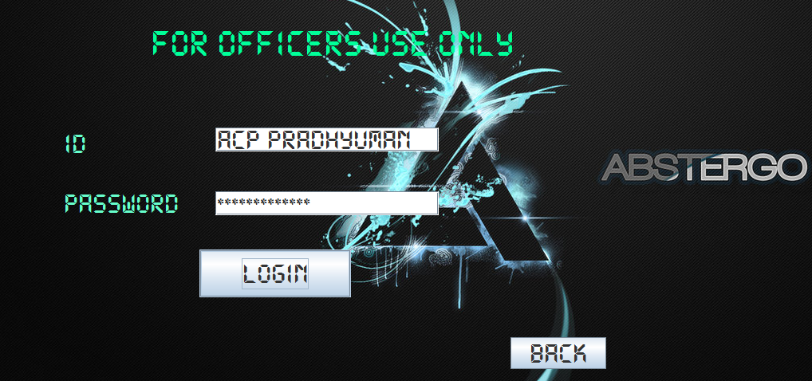

18) The Main Head of Officers, can search any detail of any complaint.

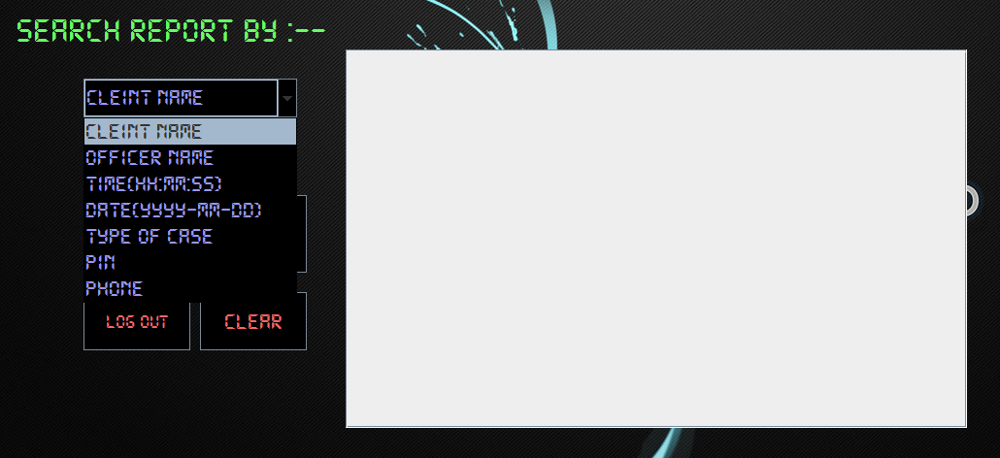

19)The Report is now visible to Main Head of Officer, that is “ACP PRADHYUMAN”

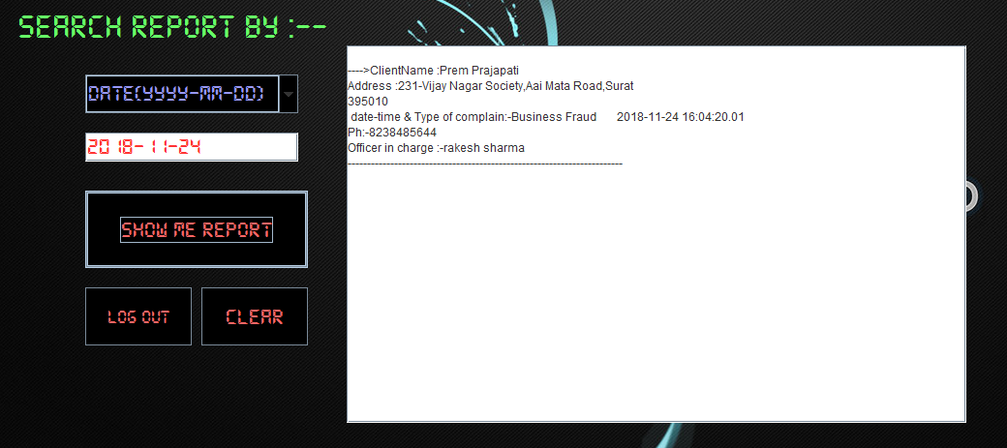

20) When He, clicks on CLEAR button, Report gets cleared.

And , when LOG OUT button is clicked, the Main Screen Opens.

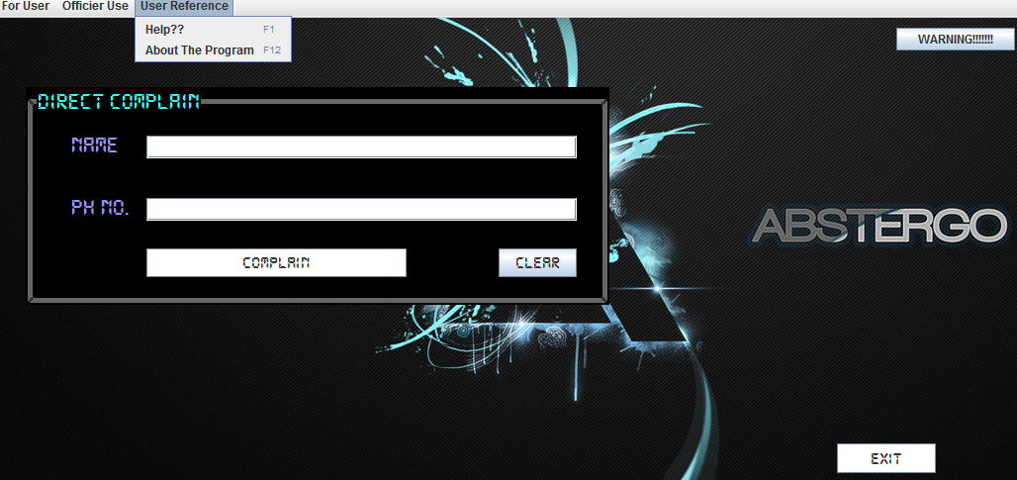

21) When USER clicks, F1 button(Help):-

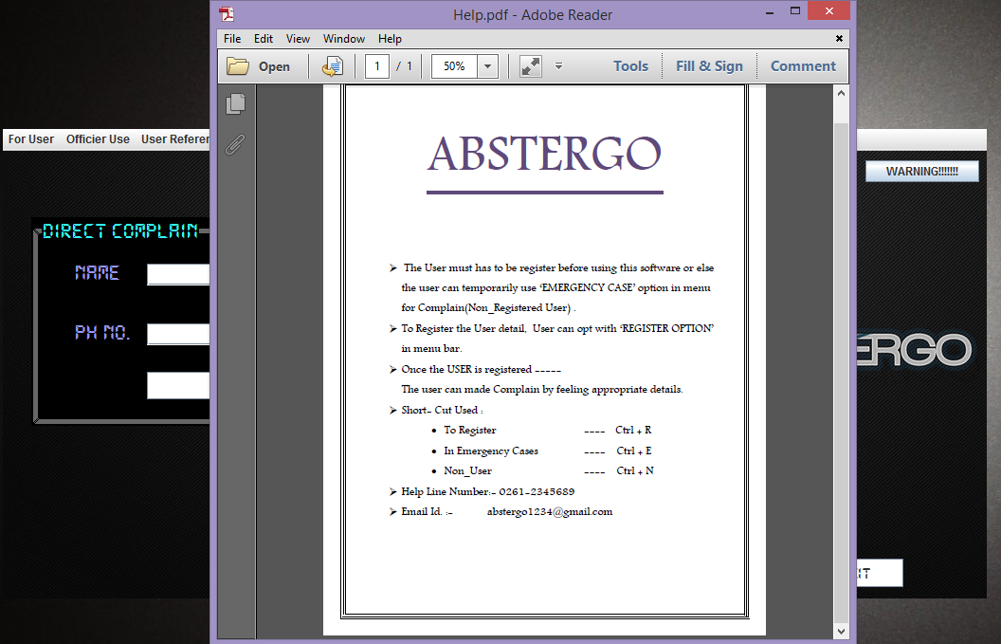

22) When USER clicks, F2 button(About The Program):-

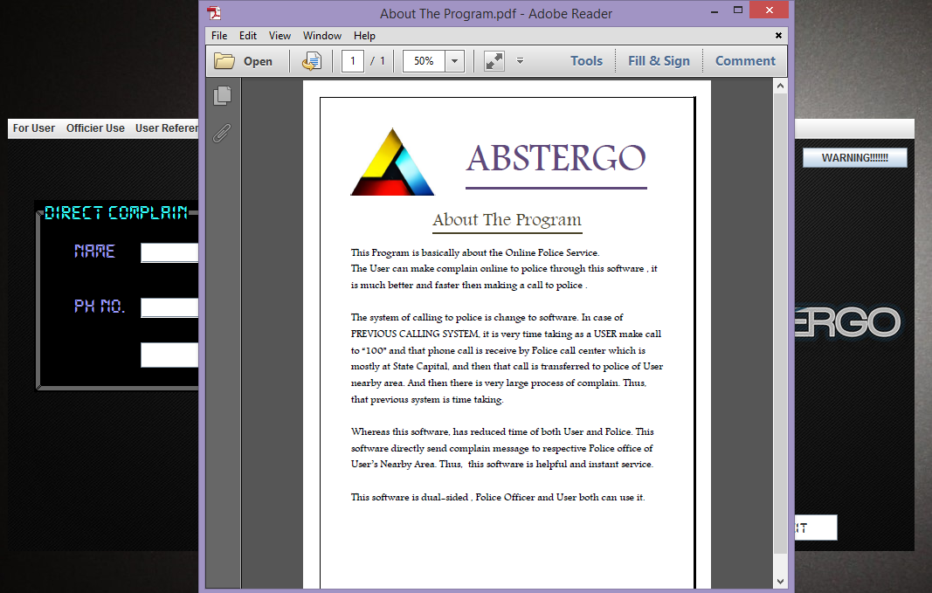

**Output screen-2**

OUTPUT WITH INCORRECT DATA

1. Non_ User enters data, without being Registered

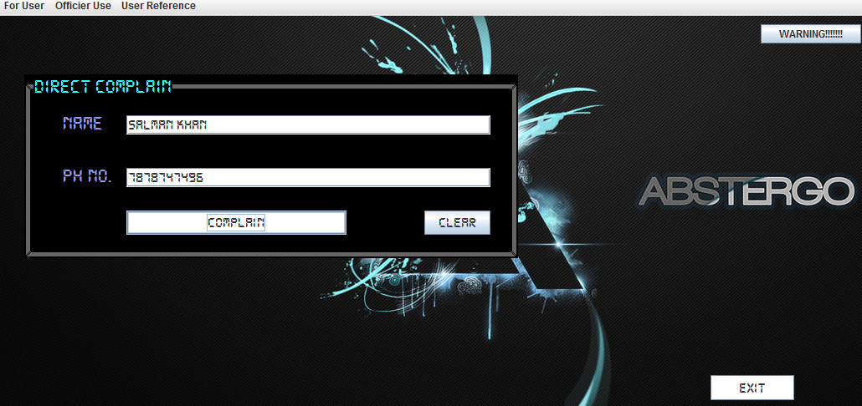

1. The USER, gets an ERROR

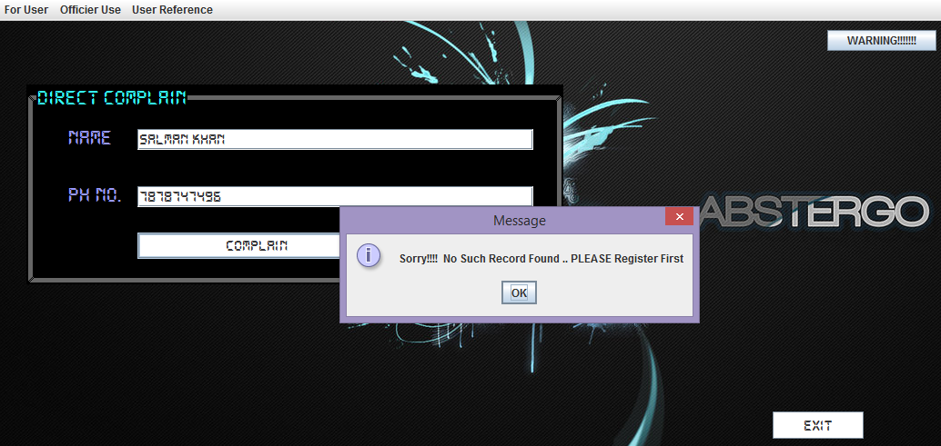

1. When Non_User enters data in incorrect fields and inappropriate data.

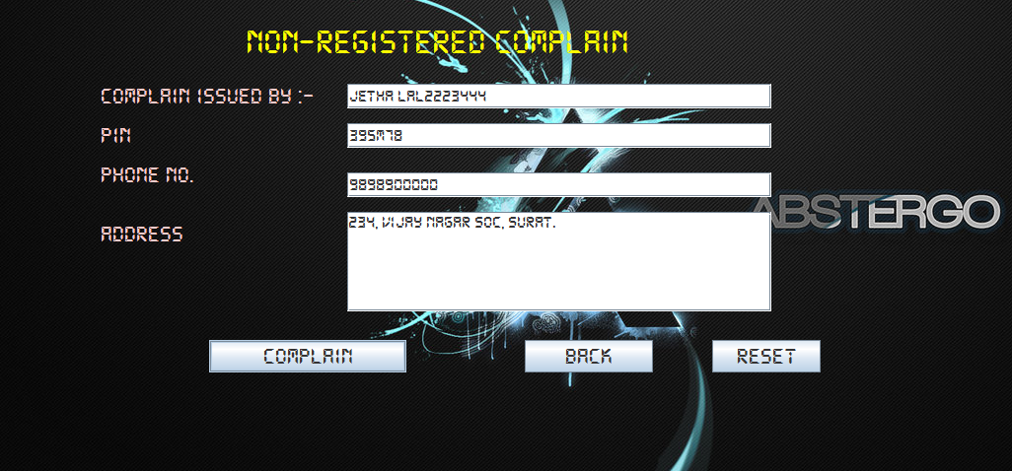

4)The User gets an ERROR, for this.

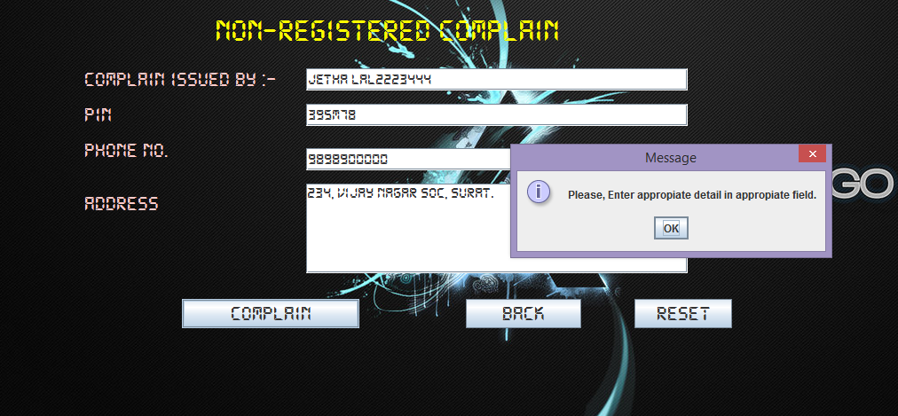

5) When USER go for Register, and enters Inappropiate Data:-

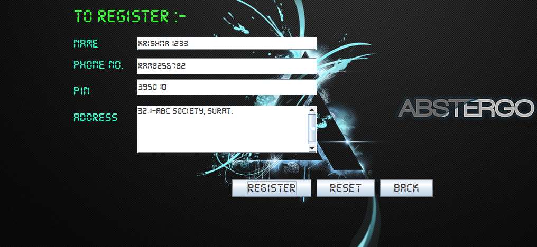

6) The USER, gets ERROR, for entering inappropriate data:-

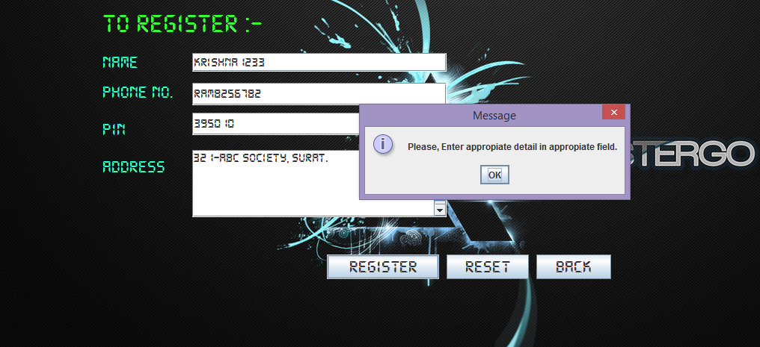

7) The Main Officer search the record, which is not present and gets an Error message.

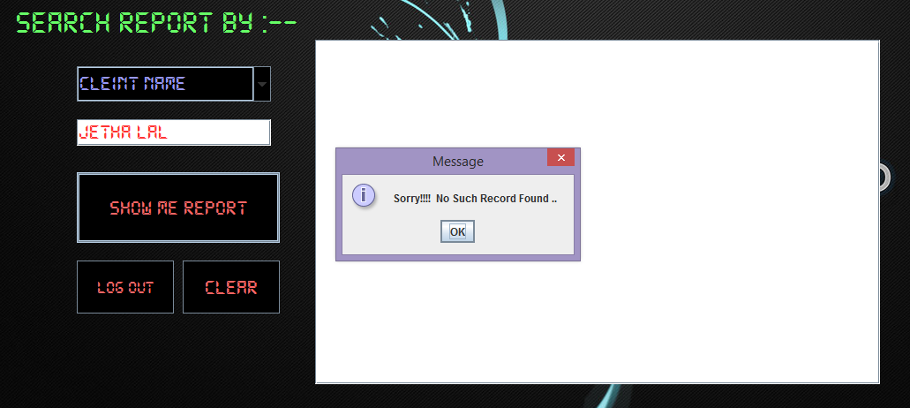

8) The Main Officer search the record, which is not present and gets an Error message

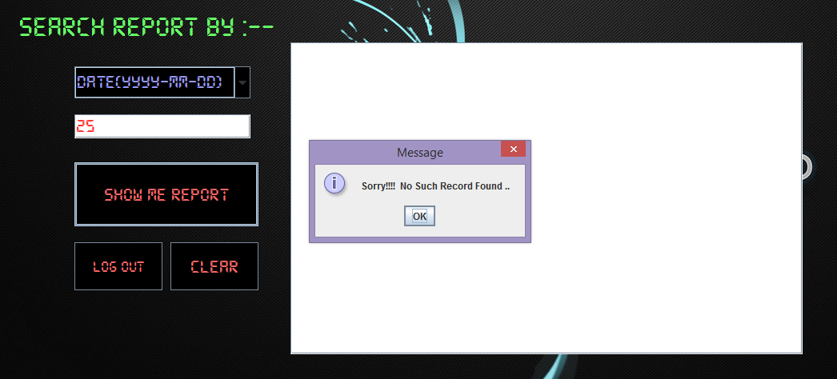

**BIBLIOGRAPHY**

* NCERT -IP
* Myspacegens.com
* YouTube
* Software

**Future updation**

* City Mapping can be added to trace location.
* Reports can be filtered on basis of solved or unsolved Cases.
* Internet Security can be added for more Privacy, avoid linking of data.
* Can be Upgrade to Phone Version for instant use or easy use.
* Photos can be added to databases of Client for better identification.